SCCA OBSERVES 2ND NATIONAL TREE PLANTING EVENT BY WAY OF GRACING THE WORLD TREE PLANTING DAY CELEBRATION
The world Tree Planting Day that falls on the 3rd August every year was declared by the United Nations in recognition of the important role of the forest for our survival and the threats the forest is facing due to logging, wide fire, settlement, farm land, other environmental degradation etc.
Shout Climate Change Africa is a non-governmental and non-political Organization that is promoting public sensitization, awareness and education on climate change issues. This year, SCCA collaborated with the world players to commemorate this day, being their second commemoration. The first one last year was done at the Prince of Wales School Compound with some twenty symbolic trees planted and this year at the S.O.S Hermann Gmeiner International College and Technical Vocational Institute –Goderich campus.
The event attracted wider attention most especially; The Executive Chairperson-Environmental Protection Agency- Dr. Foday Moriba Jaward who physically graced the event. His presence at the event was not only felt by the hundreds of guest who attended the program (ranging from community stake holders, to students and people from various sectors), but also a pointer to his commitments and determination to handle national environmental issues.
Seeing the seriousness with which SCCA attached to Climate Change and Environment issues, DR. Foday M. Jaward assured SCCA of his support at all times that will promote their organization and that their duet relationship would continue to be stronger. At the event Dr. Jaward HAS THIS TO ARTICULATE:
“I must say it is a privilege for me, and an honour in support of this worthy tree planting exercise to grace the occasion of the 2nd World Tree Planting Day... I want to take this opportunity to specially thank Shout Climate Change Africa, and key partners for this laudable initiative. SCCA and partners are making an important gesture in making a little but significant contribution towards mitigating the environmental problems we face today. Today, as a symbolic gesture, we are having a tree planting ceremony as part of the activities for the celebration of World Tree Planting Day. As we all can attest, this demonstration has a very significant outcome and is potential to bring a change in our societies”.
Dr. Jaward furthered as follows: “Distinguished guest, why tree is a symbolic entity for cleaning the environment? ...It reminds us of nature and the importance of environmental protection. As trees grow, they help on climate change by removing carbon dioxide from the air, storing carbon in the trees and soil and releasing oxygen into the atmosphere. This is a single sign behind planting trees”. As part of his key note speech, the Executive Chairperson-EPA added that trees should be regularly planted to replace deforested ones and to maintain the life that they are supplying to us.
By way of constructing the Tree Planting Ceremony, Madam Doris Nenneh Massaquoi the Director for Shout Climate Change Africa shows her kindest sense of appreciation to the guest of honour Dr. Foday Moriba Jaward- the Executive Chairperson-EPA; and all guests to the event. SEE WHAT SHE HAS TO SAY: “May I welcome you all with precious regards on this important occasion, for gracing, celebrating and planting trees with us today.
It is a joy to be here, as today marked our 2ndtime joining the World and the International Community for the Celebration of World Tree Planting Day. In response to the unfortunate environmental conditions caused by reduction in the number of trees in our land which have not just degraded the land surface but has also necessitated to serious surface run-off during heavy rain falls and squalls, streets flooding within Freetown municipality have also been eminent resulting to destructions. As Climate Change actors/activists we are bound to devote our commitments in line with United Nations Sustainable Development Goal 13 that calls for Urgent Climate Action. It is against this backdrop that we are gathered here today to plant trees for the present and for the future”.
SCCA Director–Doris Massaquoi further commended government efforts for the introduction of 1stSaturday nationwide monthly cleaning, which she says is essential for tackling environmental problems in the country.
She ends with the following words: “In our daily living, we all require regular reminders of our relationship with the environment. The good health of our land is essential to our own health and well-being, and to our future, and trees are an essential part of it. We welcome the presence of our honoured guest speaker and partners for joining us PLANT TREES FOR LIFE. Indeed, trees play an essential role in mitigating environmental disasters. Planting trees is one of the most important things we can do to contribute to the health of our societies. Trees are important component of the breathing cycle, drawing in carbon dioxide and breathing out oxygen. Strategically planting trees can help beautify our landmark and reduce surface-flooding both of which have been eminent in the country. Trees in urban towns filter the air and remove harmful particles. They also help to filter and regulate water, preventing flooding and protecting watersheds. They reduce noise pollution by shielding homes and offices from roads and industrial areas. They provide a hospitable place for animals to live and other plants to grow.
If you visited some of our National Parks or beaches; you would see how trees can promote health and relaxation. We are here today to plant trees for life and to provide information about the importance of trees and why we should keep them safe”.

Dr. Jaward then called on the gathering and all Sierra Leoneans to challenge themselves by making a change in the country by handling the environment properly. He told of the past tree planting exercises through secondary school empowerment EPA has undertaken in the past. He reminds all and sundry that every single person has a role/responsibility of protecting the environment by way of appreciating life and promoting healthy living. Dr Jaward continued that by planting trees, we can partake in rescuing our forests from destructions. He emphasised that the efforts of Shout Climate Change Africa to include their commence collaboration in symbolic tree planting is a clear manifestation that many people nowadays have known that trees are crucial part of life and it is important for us to learn how to handle and protect them. He concluded by giving a quoted statement from SCCA: “I was very touched when I read the letter and I will quote some words from the invitation...”The red flag is up, climate change is real; all hands must be on desk to fight against change...”
He joined others by symbolically planting a Tree before his departure.

The National Student Representative Carolyn Afua Owusu Afriyie extends a special thanks to Mr. John F. Asibor- Shout Climate Change Africa CEO for inspiring students to becoming ardent environmental advocates. She expressed her hearty congratulations to Shout Climate Change Africa partners in environmental safety advocacy like the EPA, the Freetown city council, Sierra Leone Red cross Society, the Ministry of Agriculture, Ministry of Tourism, LANDS and other line ministries, partners and all the participants for their active participation on this event.
The national representative of students Carolyn brings this quotation from the current UN Secretary-General “According to the ninth Secretary-General of the United Nations António Manuel de Oliveira Guterres, he once stated @ a Tree-Planting Ceremony on the Occasion of The International Day of Forests as”..., “Trees are mysterious, wonderful and ancient. Plants and forests are hundreds of millions of years old, while Homo sapiens have been around for just 250,000 years”.
She precedes by acknowledging and appreciating government efforts for enforcing environmental sanitation within the school environs, and for enforcing /incorporating ENVIRONMENTAL RULE OF LAW in the country. She also thanked the Education Ministries for ensuring liberalization of the educational system across the country. Carolyn articulates thus: For the ancient Greek philosopher PLATO (one of the best students of Socrates) in one of his famous writings once mentioned that: “Human life without proper education is like a lifetime prisoner without plan for the future” and that: “Societies can only grow when its people are able to read and write strongly…illiterates & semi-educated members of every clan are the major drawbacks to Philosopher King’s failure”. With this in mind, I now call on all likeminded Sierra Leoneans to collaborate, and pray for success in His Excellency’s Free Education Scheme, & all his vision for the country’s development. Of course Reforestation and tree planting is part of his vision for Environmental Protection which is why we are here.
She concludes her tree planting remarks with another Quotation: the American scientist, and geobiologist Hope Jahren Bill has said, “People don’t know how to make a leaf, but they know how to destroy one”. Which she interprets in French as: les gens ne savent pas faire une feuille, mais ils savent comment en détruire un. She also provides its latin version as : « Non sciunt folium perderet sed quam”.

The tree planting exercises was climaxed with some key home-based Artistes: Ark-Man, Collabo, and J. Cleff all of whom also joined us PLANT TREES FOR LIFE.

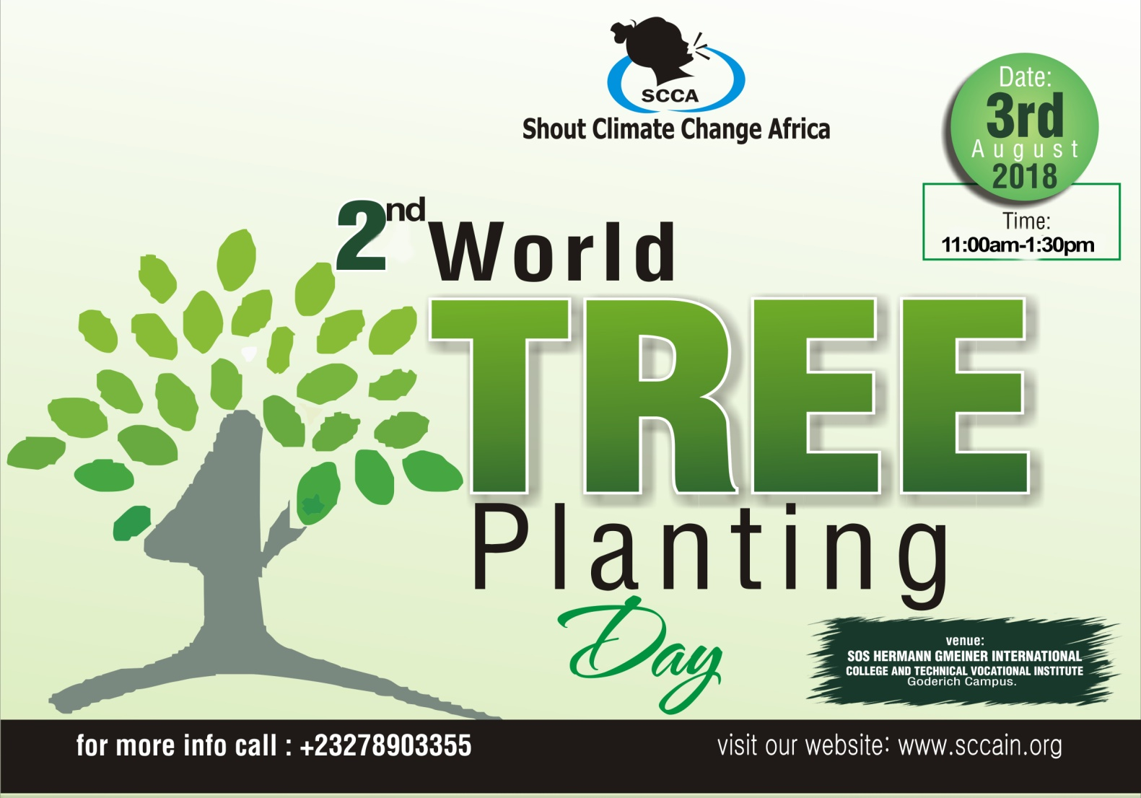
EPA Boss – Dr. Foday M. Jaward symbolically planting tree

